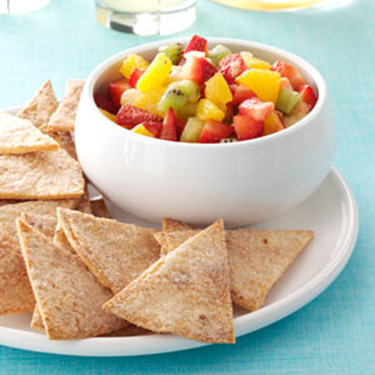
Fruit Salsa

Ingredients:
3 cups of your favorite salsa
1 medium navel orange, peeled, finely chopped
1 can (small 8 oz.) crushed pineapples
1 mango peeled and finely chopped
1-2 apple finely chopped
1 pear or peach, peeled, finely chopped
1 cup of strawberries, finely chopped
Optional: Kiwi, grapes, or other seasonal fruit
***Combine, chill, and serve with chips!

